CRT
Title of the Program : Full stack with python
Target Audience : IV Year Students from CSE, ECE selected students
Venue : Anantha Lakshmi Institute of Technology and Sciences
Date : 20/04/2026 to 23/05/2026
Time : 9.00FN to 12:30 AN to1:15AN to 5.00AN
Mode : Offline
TrainerName : Mr.Senthil Narayanan and Bhargav from Learns square technology
No of Students : 98

PHOTOGRAPHY OF THE EVENT

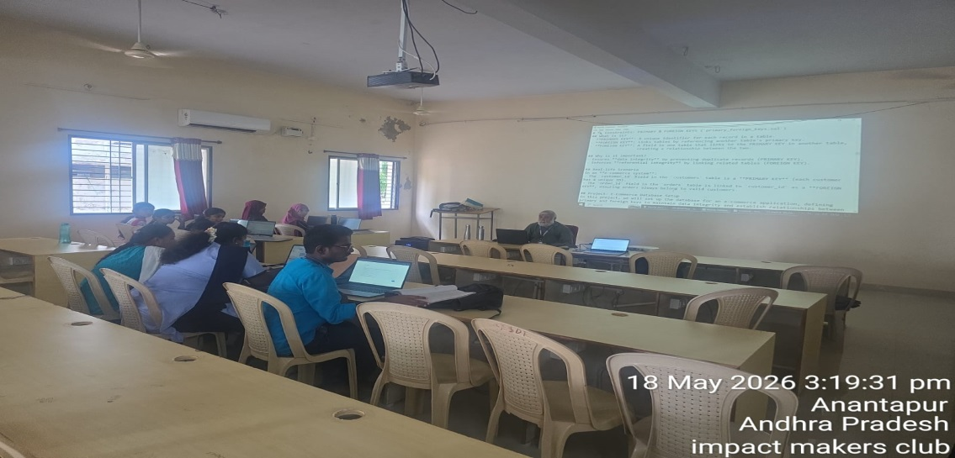
Figure 1: Trainer explaining the topics

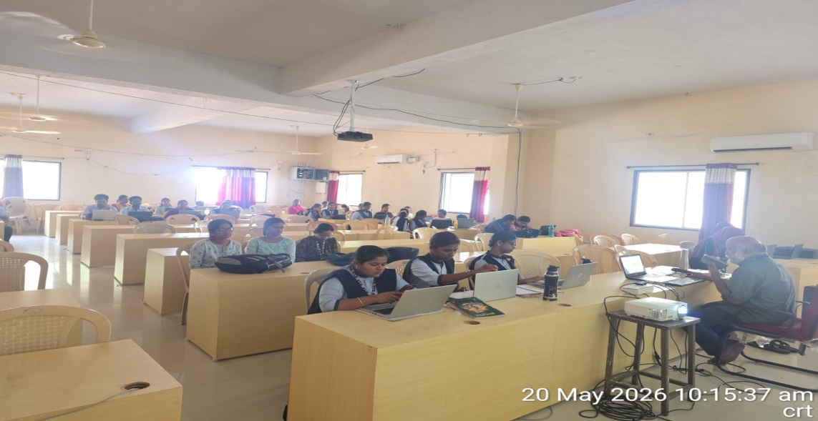
Figure 2: Students attended for the training

