CRT

Report on Campus Recruitment Training: Full Stack with python
Title of the Program : Full Stack with python
TargetAudience : III Year Students from ECE, CSE.
Date : 18/05/2026 to 20/06/2026
Time : 9.00FN to 10:00 FN to10:15FN to 11.15FN
Mode : Online
TrainerName : Kiran mai
NoofStudents : 228
PHOTOGRAPHY OF THE EVENT

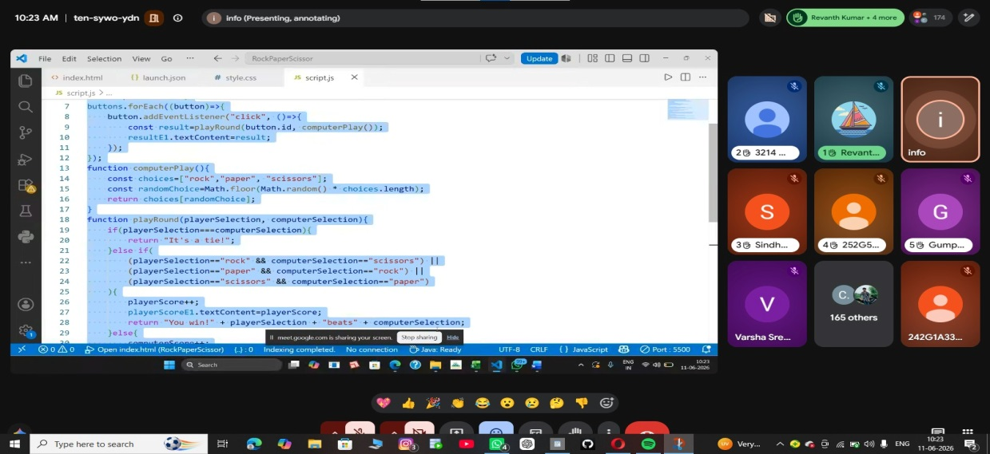
Figure 1: Trainer explaining the topics

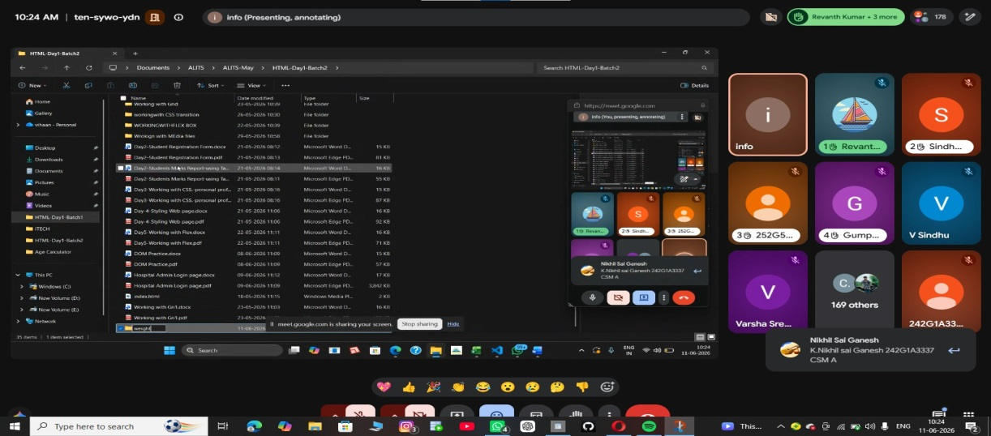
Figure 2: Students observing the topics

