CRT

Title of the Program : Non-technical training
Target Audience : III Year Students
Venue : Anantha Lakshmi Institute of Technology and Sciences
Date : 01/09/2025 to 26/09/2025,
8/10/2025 to 18/12/2025 &
19-02-26 to 25-02-26
Time : 9.00FN to 12:30 AN to1:15AN to 5.00AN
Mode : Offline
Trainer Name : Mr Bhaskar Reddy
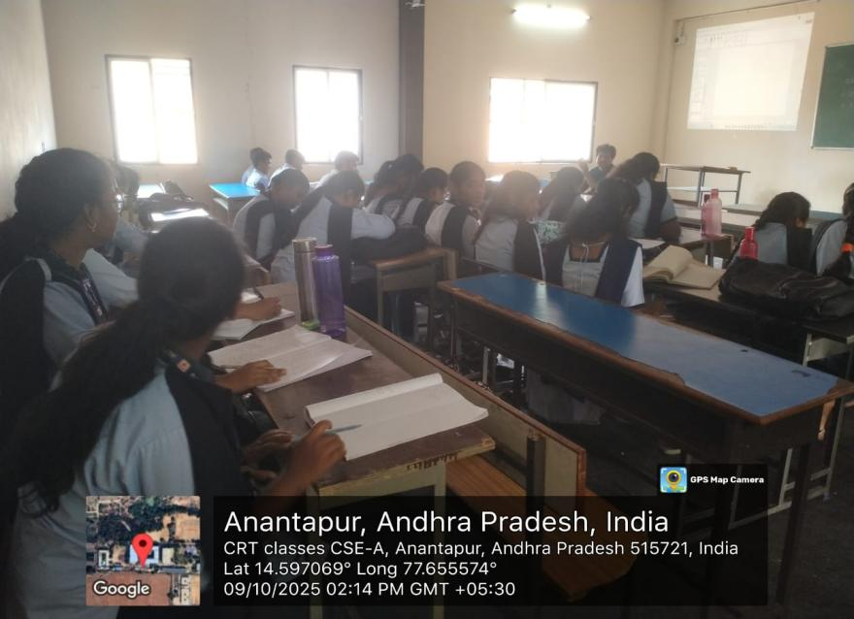
No of Students : 177

